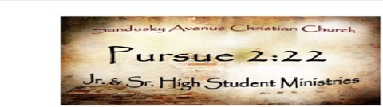
PURSUE 2:22 Youth Ministry CALENDAR 2026 (UPDATED 4-14-26)
PURSUE 2:22 - 2 Timothy 2:22 (NLT)
Run from anything that stimulates youthful lusts. Instead, pursue righteous living, faithfulness, love, and peace.
Enjoy the companionship of those who call on the Lord with pure hearts.
Wednesday Nights
“The Table” 6–7:30 PM Pursue 2:22 High School & Jr. High Youth Small Group Bible Study - Youth Room
(No Wednesday Night Activities on Holiday Weeks, or Weeks during Youth Events)
Sunday Nights
5–7 PM on Sunday Nights - High School & Jr. High Youth Group
Check your texts for updated locations Bring your friends, bring snacks & drinks to share!
We eat, play some games, have a devo, and have a ton of fun together!
(No Sunday Night Activities on Food Pantry Sundays, Holiday Weeks, or Weeks during Youth Events)

Parents & Students: Please pay for all events online on our website www.sanduskyave.com under connect / students.
If you choose to pay in cash or check, please place your payment in a PURSUE 2:22 payment envelope and fill out the front completely.
PURSUE 2:22 Payment envelopes are available in my office, the lobby, and in the youth room.
Questions?: Text, Call, or E-mail Jimmy @ 918-497-0628 / or jimmy.foreman@sanduskyave.com

Communication for all Youth Functions / Events will be done through the Remind App @ pursue2-22 (Class Name PURSUE 2:22)

Special 2026 Upcoming Events
HANDS & FEET FOOD PANTRY DATES: April 19th, May 17th, July 19th, August 23, September 20th, October 18th, November 22nd, December 20th
(Food Pantry s immediately after service – IN THE GYM on 3rd Sunday of the Mo nth-Except Holiday Weekends – from 11:30am – 2 pm)
Youth Events
Registration & Payment for Camp due April 30th
Summer Kick Off – May 17th
Last Day of School for TPS – May 28th
CIY MIX Registration & Payment due June 1st
High School Camp – May 31st – June 5th
Middle School Camp – June 7th -12th
CHRIST IN YOUTH MIX
SUMMER CONFERENCE 2026 (for 6th – 8th Grades)
July 6th – July 10th
in Siloam Springs @ John Brown University
Lake Day – Sunday July 26th
Back To School Bash – Wednesday, September 9th
Fall Retreat – October 16-18 @ Sunset Bible Camp
Christmas Party – Sunday, December 6th

This QR Code will direct you to the Student page of our website where you can Sign Up, Register, & Pay for Camp & CIY MIX


Romans 7:15

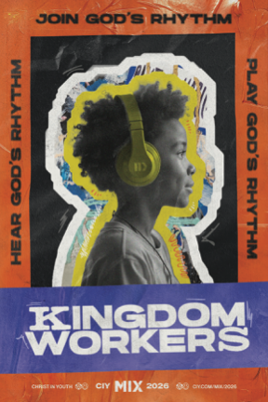
Sunset Bible Camp 2026 “GRAVITATE”
High School Camp Week May 31-June 5
Middle School Camp Week June 7-12
Cost: $50 before April 30th /
$75 After April 30th
$255 Before April 30th if you did not work the Garage Sale
$280 After April 30th if you did not work the Garage Sale
_______________________________________
CIY MIX “Join God’s Rhythm”
July 6-10, 2026
Cost:
$50 due by June 1st / $75 after June 1st if you worked the Garage Sale
$400 due by June 1st if you did not work the Garage Sale

